Submitted By: U19CS012 (D-12)

BHAGYA VINOD RANA | C.S.E., SVNIT

DIGITAL ELECTRONICS & LOGIC DESIGN LAB

Lab 1: Assignment 1 & 2

**Assignment –1**

*a.) Implement the circuit as shown in Figure in Multisim online.*

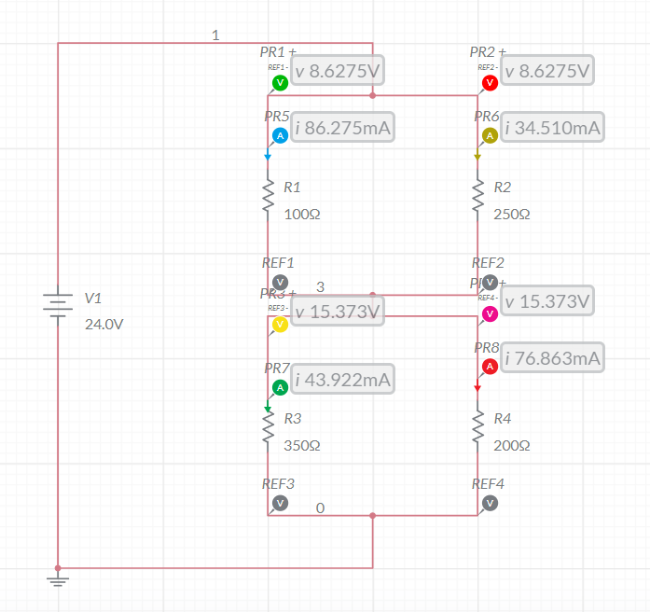

*b.) Evaluate the current and voltage across each resistor using simulator.*

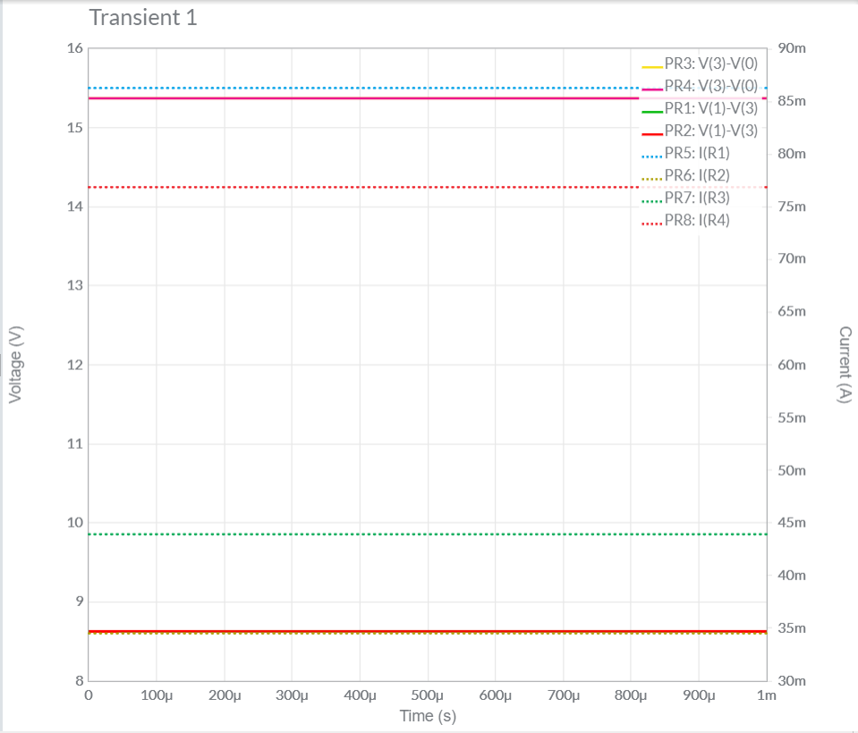

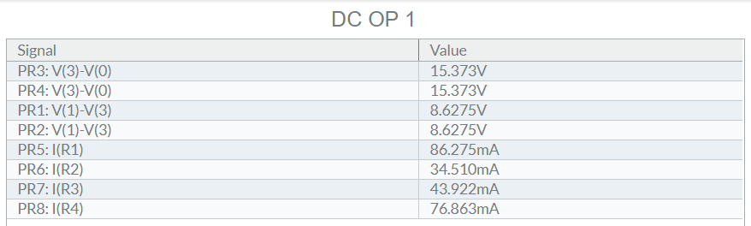

*c.) Compare with theoretical values.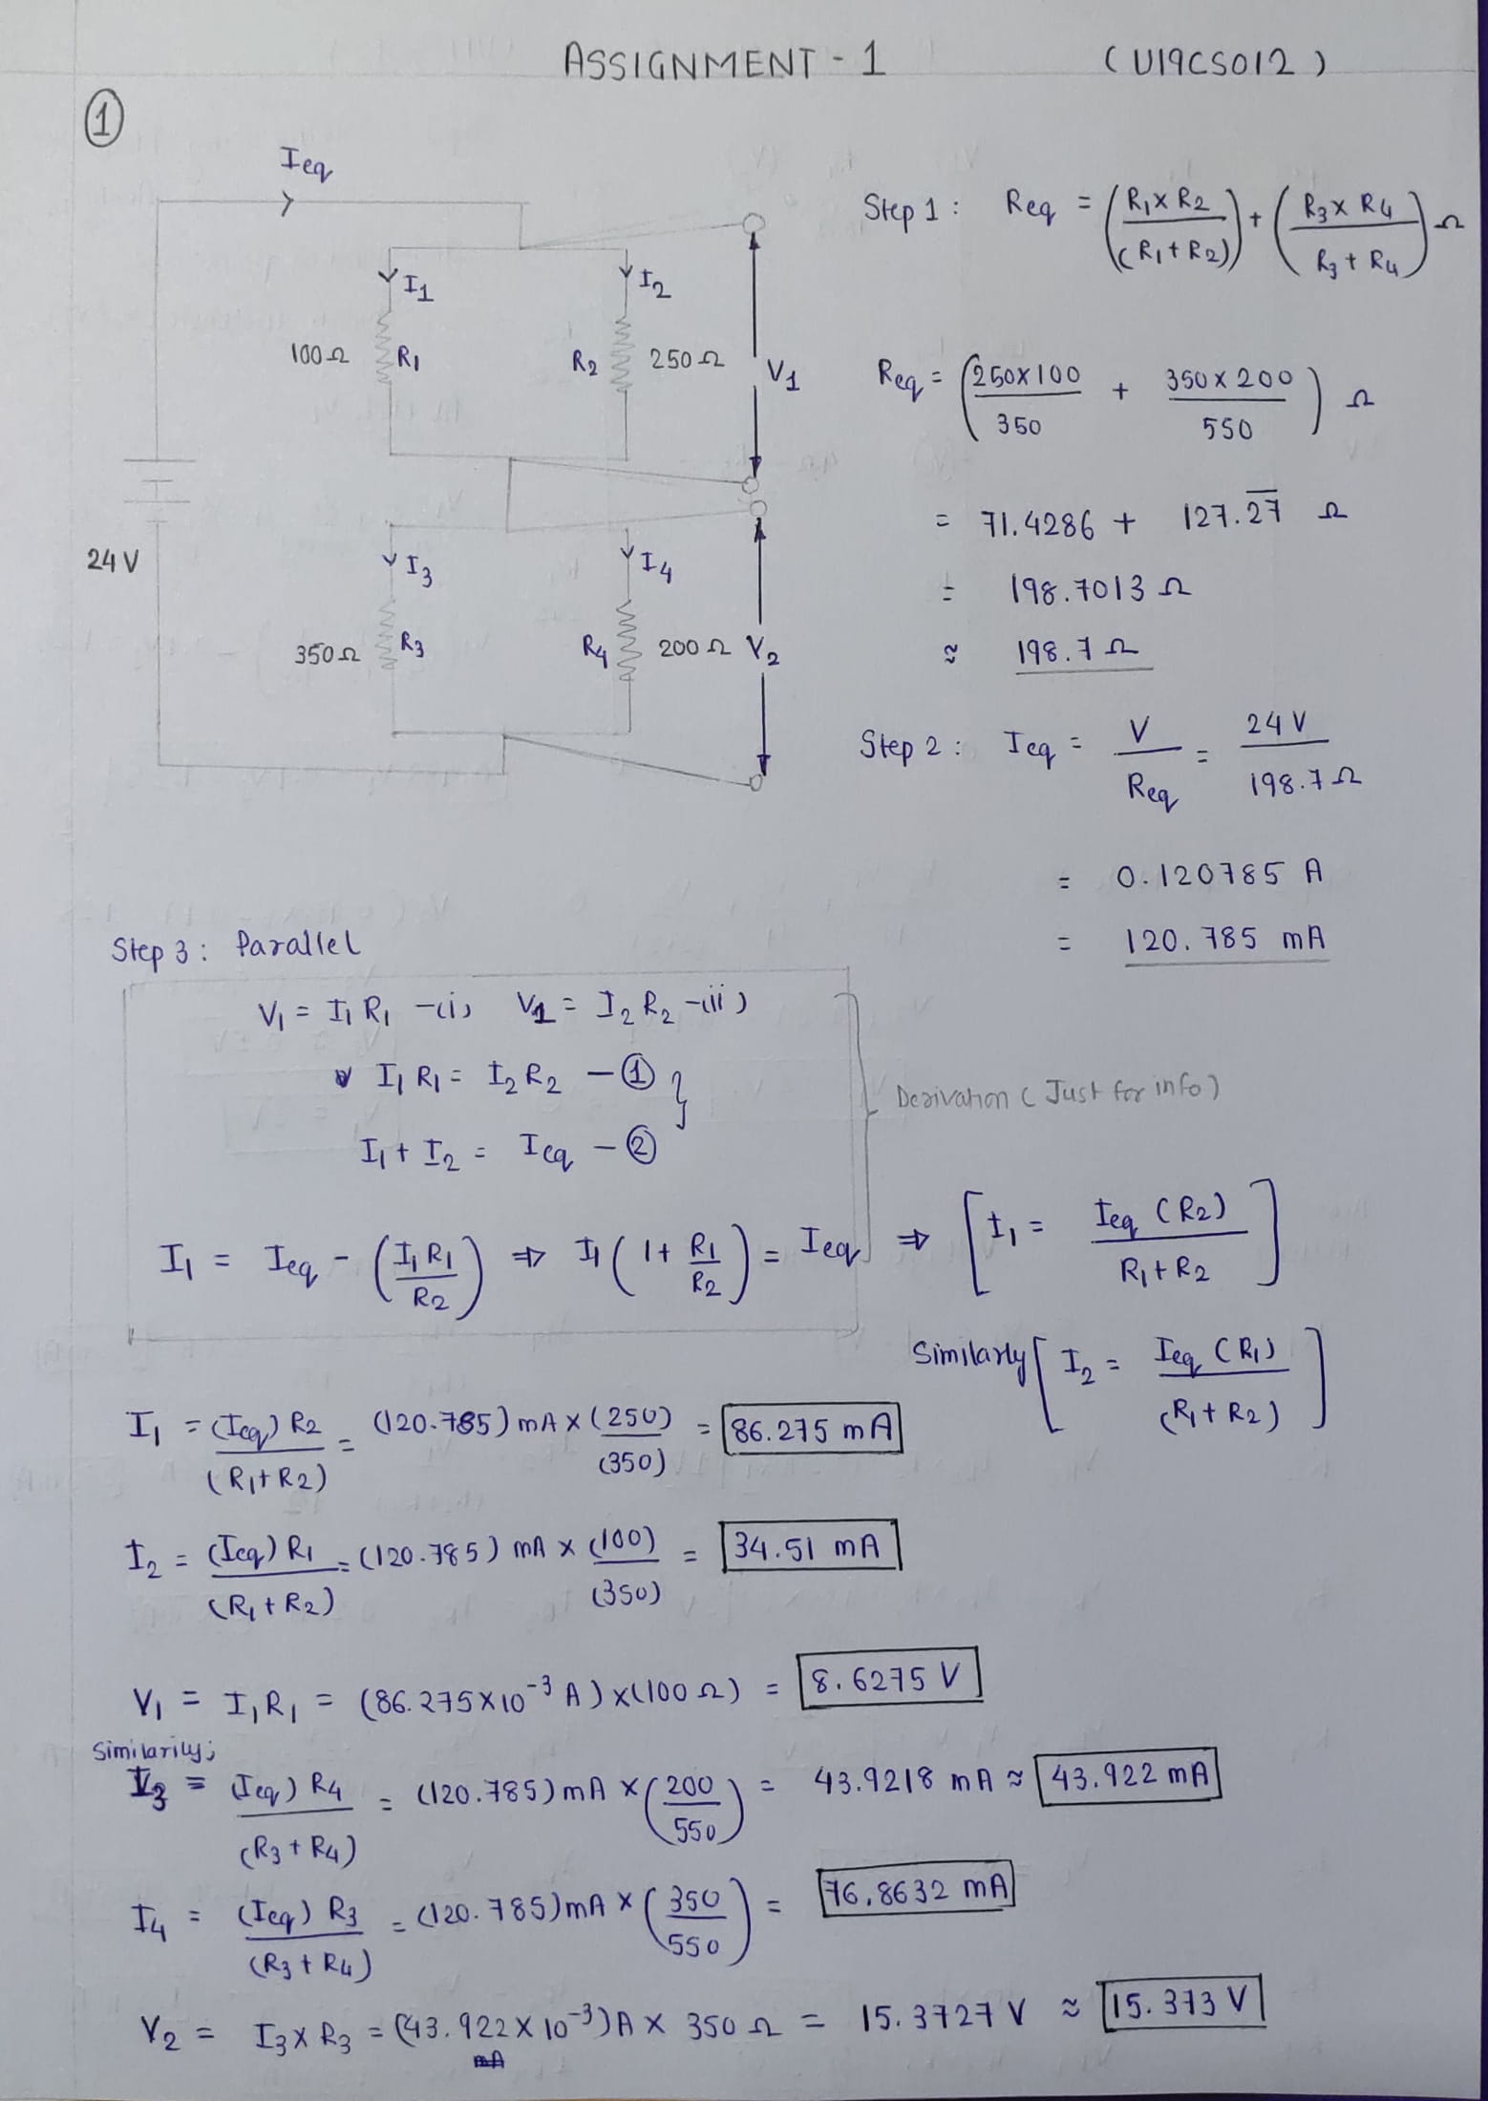*

*d.) Final Result and Conclusion*

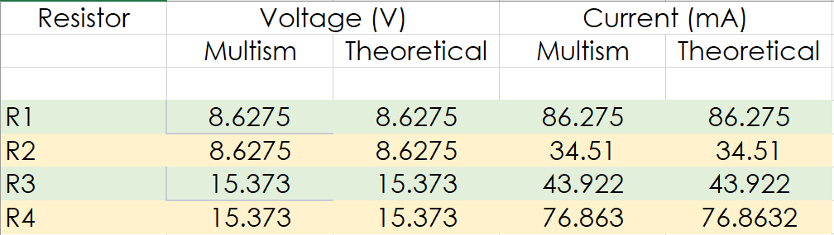

*Conclusion:*

We can observe from Above Table, Both the *Theoretical* and *Multisim* Values of Current and Voltage are **Equal**.

Hence, Experiment is Performed Successfully (without any Error).

**Assignment –2**

*a.) Implement the circuit as shown in Figure in Multisim online.*

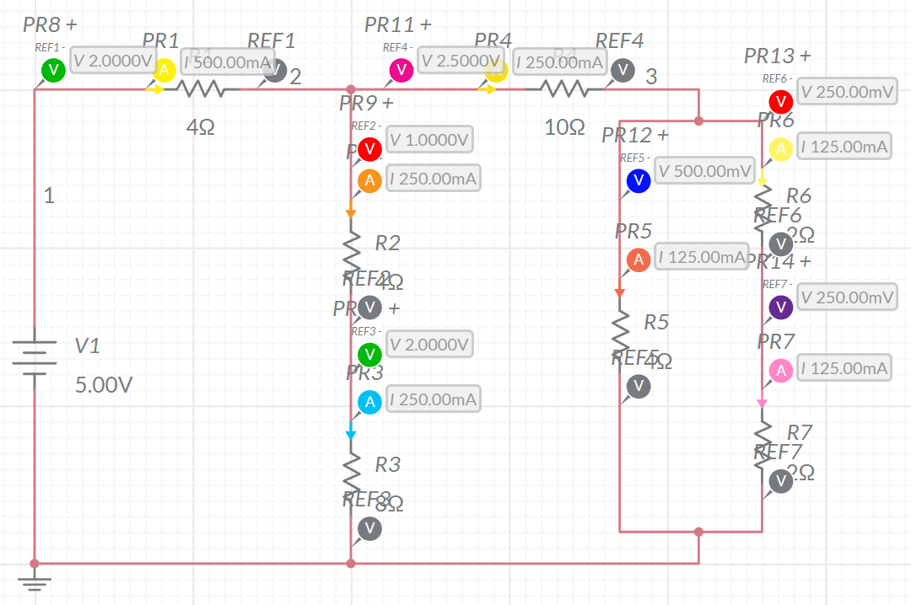

*b.) Evaluate the current and voltage across each resistor using simulator.*

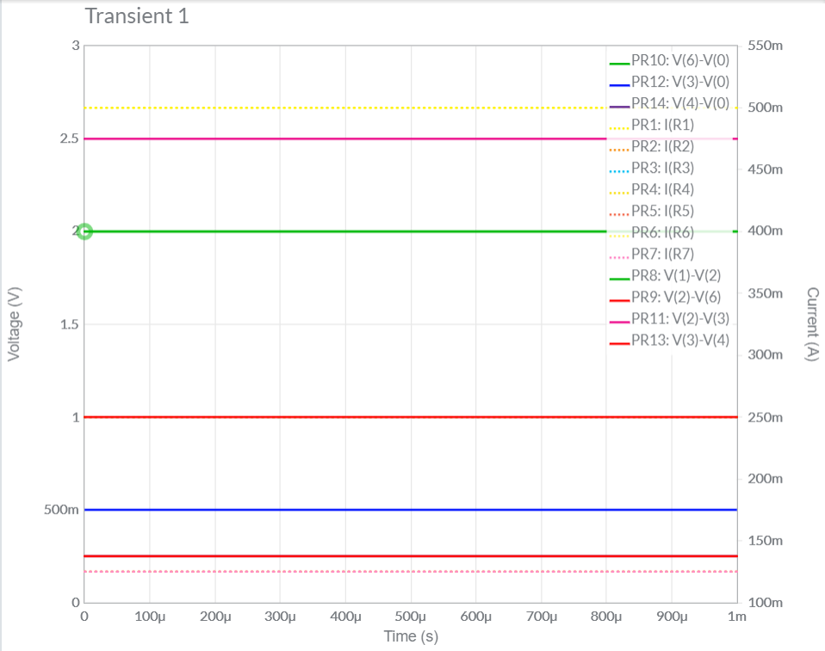

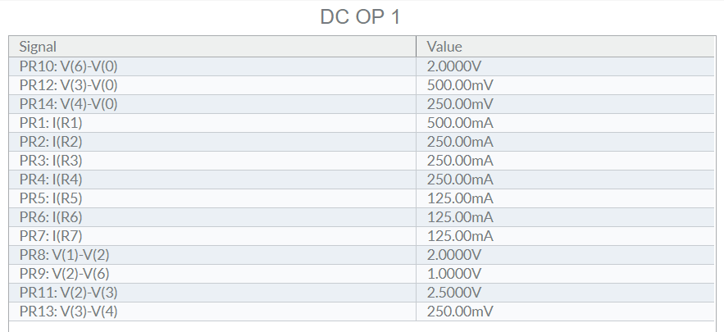

*c.) Compare with theoretical values.*

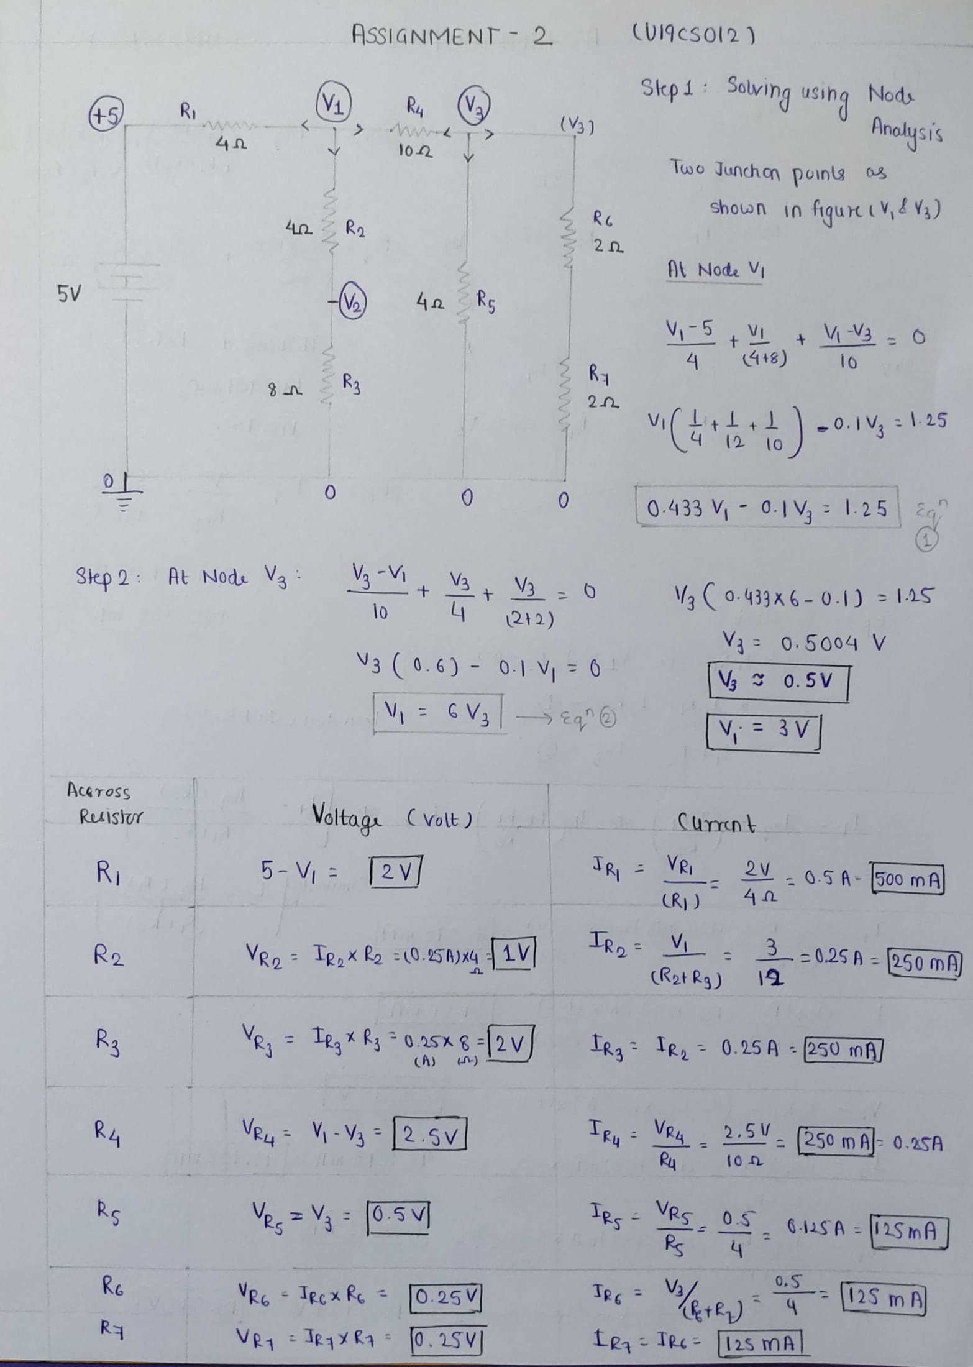

*d.) Final Result and Conclusion*

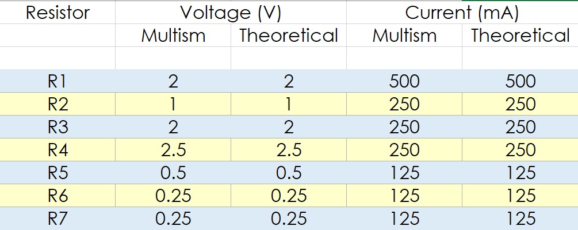

*Conclusion:*

We can observe from Above Table, Both the *Theoretical* and *Multisim* Values of Current and Voltage are **Equal**.

Hence, Experiment is Performed Successfully (without any Error).

Submitted By:

Roll Number: U19CS012 (D-12)

Name: Bhagya Rana